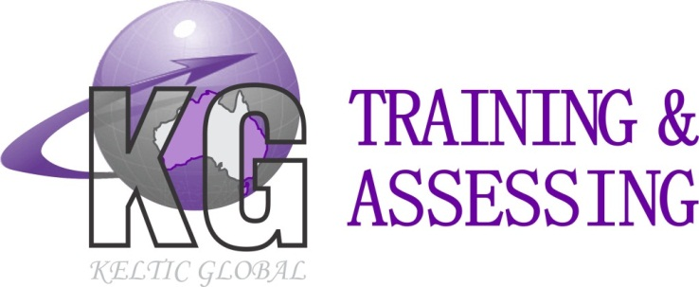
ABN: 421 334 328 63
Location: Unit 1/8 Day Road, Rockingham WA 6168
Postal Address: PO Box 2111Rockingham DC WA 6967
Ph: 08 9592 2535 Fax: 08 9592 2757
Office Email: admin@kgtraining.com.au
Web: www.kgtraining.com.au

Advanced Rigging Course Equipment List
The following equipment must be provided in order to meet the practical assessment requirements, however this is not an exhaustive list and further equipment will be required. Before we can confirm all items needed you will need to confirm that you can provide all items listed below, and also confirm the specific components you intend to provide for each task itemised below.
- Any required documentation applicable to the site, e.g. risk assessment. If a risk assessment is not used, please inform KG Training so that we may supply our own document
- A suitable room to conduct training in, with a whiteboard if possible
- Communications equipment (e.g. Two way radio)
- Defective equipment for identification purposes
- Power and manually operated lifting gear
- Tag lines
- Flexible steel wire rope (FSWR)
- Chains
- Wire and synthetic slings
- Shackles
- Terminations
- Eye bolts
- Beam clamps
- Rope grips
- Turnbuckles
- Rigging screws
- Lever blocks
- Lever-action winches
- Sheaves
- Scaffold and rigging tools
- Jacks
- Levers
- Skates
- Wedges
- Rollers
- Girder trolley
Task: Install a Static Line
- A static line to install
- The necessary tools and equipment to install the static line
- Harnesses and lanyards
- A structure to install the static line on
- Appropriate PPE
- Appropriate hazard controls

Task: Rig a Flying Fox
- The required components for a rope system meeting the following minimum standards:
  - Span distance of at least 10 metres
  - Able to support at least 200 kilograms
  - The rope span may be supported from fixed anchorages, poles, or both.
  - Anchorage height of at least 4 metres
- A load of minimum 200kg and slinging equipment
- The necessary tools and equipment to install the flying fox
- A structure to install the flying fox on
- A means of work at heights to install the flying fox, and fall arrest equipment
- Appropriate PPE
- Appropriate hazard controls
Task: Install a Suspended Scaffold (Swing Stage)
- A suspended scaffold meeting the following minimum standards:
  - Height of four metres or more.
  - Attached by a dual needle system using counterweights.
  - May be powered electrically or manually.
  - Able to support 200 kg or more
- The necessary tools and equipment to install the suspended scaffold
- A structure to install the suspended scaffold on
- A means of work at heights to install the suspended scaffold, and fall arrest equipment
- Appropriate PPE
- Appropriate hazard controls
Task: Set Up a Gin Pole and Conduct a Lift With a Powered Winch
- The required components for a gin pole meeting the following minimum standards:
  - Height of at least eight metres.
  - Weight to be lifted of at least 400 kilograms.
  - The winch must be powered with at least one diversion sheave
- A powered winch
- A suitable means of securing the winch and anchoring diversion sheave/s
- The necessary tools and equipment to set up the gin pole
- A means of lifting the gin pole into position
- Slinging equipment suitable to the load
- Appropriate PPE
- Appropriate hazard controls
Task: Install and Remove a Fabricated Hung Scaffold
- A fabricated hung scaffold meeting the following minimum standards:
  - Supporting platform or beam height of at least four metres
  - Must be at least 3.6 metres long.
  - Must be heavy duty.
  - Must be made of tube and coupler.
  - There must be at least one lift, including guardrails and toe boards, below the supporting platform or beams.
- The necessary tools and equipment to install the hung scaffold
- A structure to install the hung scaffold on
- A means of lifting and positioning the hung scaffold (if a crane is used, a crane operator must also be provided)
- A means of work at heights to install the hung scaffold, and fall arrest equipment
- Appropriate PPE
- Appropriate hazard controls
Task: Erect, Operate and Dismantle a Guyed Derrick
- The required components for a guyed derrick with a minimum height of 8m
- The necessary tools and equipment to set up the guyed derrick
- A means of lifting the mast / boom into position
- A suitable load
- Rollers / skates to move the load
- A load and slinging equipment suitable to the load
- Appropriate PPE
- Appropriate hazard controls

