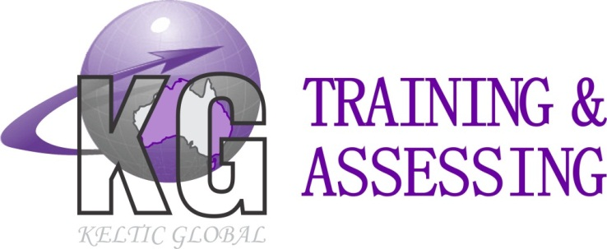
ABN: 421 334 328 63
Location: Unit 1/8 Day Road, Rockingham WA 6168
Postal Address: PO Box 2111Rockingham DC WA 6967
Ph: 08 9592 2535 Fax: 08 9592 2757
Office Email: admin@kgtraining.com.au
Web: www.kgtraining.com.au

Basic Rigging Course Equipment List
The following equipment must be provided in order to meet the practical assessment requirements, however this is not an exhaustive list and further equipment will be required. Before we can confirm all items needed you will need to confirm that you can provide all items listed below, and also confirm the specific components you intend to provide for each task itemised below.
- Any required documentation applicable to the site, e.g. risk assessment. If a risk assessment is not used, please inform KG Training so that we may supply our own document
- A suitable room to conduct training in, with a whiteboard if possible
- Communications equipment (e.g. two way radio)
- Defective equipment for identification purposes
- Sufficient fibre rope for each person on the course to practice eye splices and buntline/becket hitches, the rope must be a minimum of 10mm diameter
- Beam clamps or pipe clamps or plate clamps
- Tag lines
- Flexible steel wire rope (FSWR)
- Chains
- Wire and synthetic slings
- Shackles
- Wedge sockets
- Eye bolts
- Rope grips
- Turnbuckles
- Chain blocks
- Sheave blocks
- Spreader bars or lifting beam
- Levers/podgers
- Skates/rollers
- Wedges
- Props
- Powered winches
- Snatch blocks
- Wire rope winches
- Lever pull (e.g. Come-alongs)
Task: Install a Static Line
- A static line to install
- The necessary tools and equipment to install the static line
- Harnesses and lanyards or inertia reel
- A structure to install the static line on - installed at a height of not less than four metres working height and fitted at least 2.1 metres above the working height
- Appropriate PPE
- Appropriate hazard controls

Task: Install and Remove a CCLP
- A CCLP
- The necessary tools and equipment to install the CCLP
- A structure to install the CCLP on 4m above ground level
- A means of lifting and positioning the CCLP, and the associated slinging equipment (if a crane is used, a crane operator must also be provided)
- A means of working at heights to install and remove the CCLP, and fall arrest equipment (if necessary)
- Appropriate PPE
- Appropriate hazard controls
Task: Install and Remove a Safety Net
- A safety net (minimum dimensions 3m x 4m)
- The necessary tools and equipment to install the safety net
- A structure to install and remove safety net on, at a minimum of 4m above the ground
- A means of working at heights to install and remove the safety net, and fall arrest equipment (if necessary)
- Appropriate PPE
- Appropriate hazard controls
Task: Install and Remove a Formwork Shutter or Perimeter Safety Screen
- A formwork shutter or perimeter screen (not less than four metres high and two metres wide)
- The necessary tools and equipment to install the formwork shutter or perimeter screen
- A structure to install and remove the formwork shutter or perimeter screen on, with the top of the screen no less than five metres above the ground
- A means of lifting and positioning the shutter / screen and the associated slinging equipment (if a crane is used, a crane operator must also be provided)
- Appropriate PPE, including fall arrest equipment
- Appropriate hazard controls
Task: Erect a Structural Steel Portal Frame
- The necessary components, tools and equipment to erect a structural steel portal frame meeting the following requirements
  - At least 2 columns and 3 beams providing it is fixed to a structure, OR
  - At least 4 columns and 4 beams if the structure is to be freestanding
  - At least two girts and two purlins
  - Adequate bracing
- A means of lifting and positioning the steel, and the associated slinging equipment (if a crane is used, a crane operator must also be provided)
- Inertia reel
- A means of working at heights to bolt structure together, and fall arrest equipment
- Appropriate PPE
- Appropriate hazard controls
- A drawing/plan to be provided and approved by KG Training BEFORE a booking can be confirmed, and also to be provided during the course
Task: Install and Remove Precast Concrete Panels
- Panel specifications -
  - Panel one: not less than four metres high, not less than two metres wide, and not less than one and a half tonnes in weight
  - Panel two: not less than four metres high, not less than two metres wide, and not less than one and a half tonnes in weight
  - Panel three: not less than four metres high, not less than two metres wide, and not less than one and a half tonnes in weight. This panel must have an opening not less than the size of a door in the panel. A strong back must be available for this task
  - The panels may be constructed from any materials that will allow the required weights to be achieved within the sizes allowed
  - All panels with appropriate lifting points
  - At least one panel must be erected at a 90 degree angle
  - Note that this is NOT a tilt-up task i.e. face lifters are NOT to be used
- The necessary tools and equipment to install the panels
- A means of lifting and positioning the panels and the associated slinging equipment (if a crane is used, a crane operator must also be provided)
- A means of working at heights to install and remove panels, and fall arrest equipment
- Appropriate PPE
- Appropriate hazard controls
Task: Set Up and Operate a Winch to Move a Load
- A winch
- A load of minimum one tonne and the associated slinging equipment
- The necessary tools and equipment to set up the winch with a minimum of a two on one (three part) purchase and a diversion sheave/block; and to allow the load to be moved either vertically or horizontally
- A means of working at heights to set up a purchase, and fall arrest equipment (if necessary)
- Appropriate PPE
- Appropriate hazard controls
Task: Install and Remove a Materials Hoist or Mast Climber
- A materials hoist or mast climber with a minimum of three mast sections
- The necessary tools and equipment to install the materials hoist or mast climber
- Appropriate PPE
- Appropriate hazard controls

